PHASE 5 – APACHE KAFKA
What is Kafka ?
- Apache kafka is a distributed event streaming platform.
- Originally built by linkedin in 2011 to handle their massive data pipeline
Like millions of events per second
- Later it was open-sourced and donated to apache.
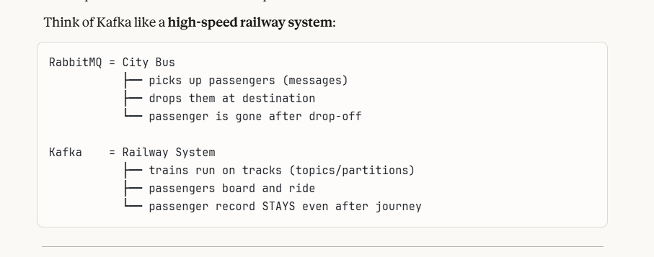

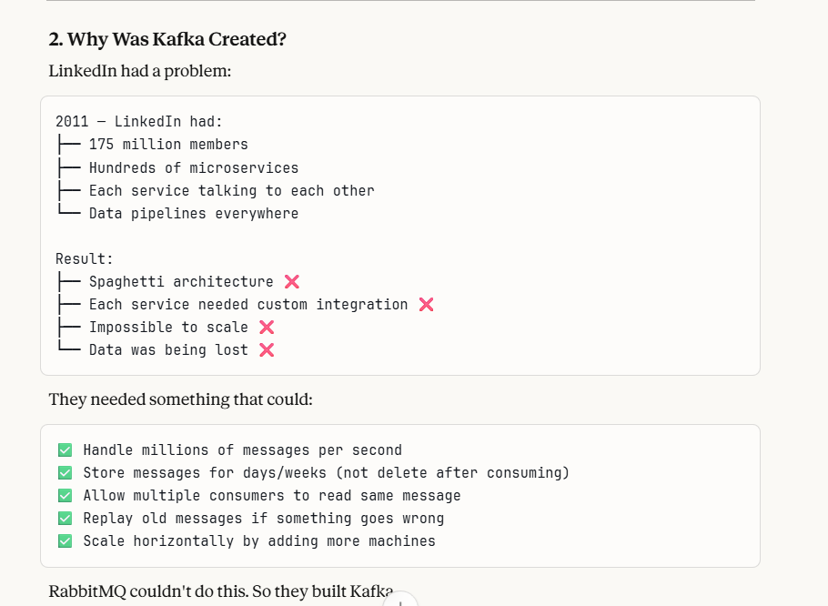

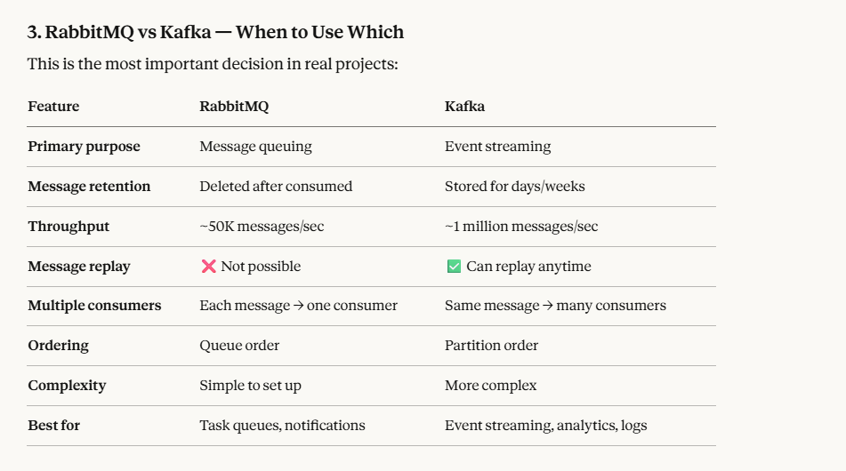
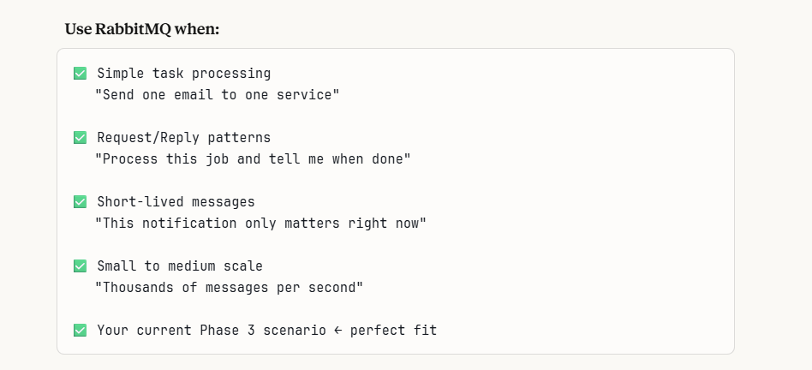
What is EventStreaming ?
Here is a simple breakdown:
- The Old Way (Request/Response): Service A asks Service B for data, and Service B gives an answer. It's like asking someone a question and getting a reply.
- The Event Streaming Way: Service A simply announces "Something happened!" (an event). It doesn't care who is listening. Any other service that cares about that event can listen and react immediately. It's like shouting an announcement into a microphone—anyone who is tuned in can hear it and act.
- 🎯 A Simple Analogy: The Package Delivery
Imagine you run an e-commerce website.
- The Event: "Order #123 was placed."
- Without Event Streaming: The "Order Service" would have to call the "Inventory Service" to reduce stock, then call the "Shipping Service" to schedule delivery, then call the "Notification Service" to email the customer. If any one of those steps fails, the order might break. The services are all tangled together.
- With Event Streaming (using Apache Kafka):
  - The "Order Service" simply writes one event: OrderPlaced into the event stream.
  - The Inventory Service is listening. It sees the event, and updates stock.
  - The Shipping Service is listening. It sees the event, and schedules delivery.
  - The Notification Service is listening. It sees the event, and emails the customer.
All three downstream services work independently. If Shipping is slow, it doesn't block Order. They all just read from the same "tape" of events.
What is an Event first?
- An event is simply record of something that happened. It's a fact recorded at a specific point in time, it has already occurred. All are immutable(cannot change what happened)
- It can be like a user clicked a button , user deleted, user paused etc
- In code terms, it's just data—usually a JSON object—that describes an occurrence.
- 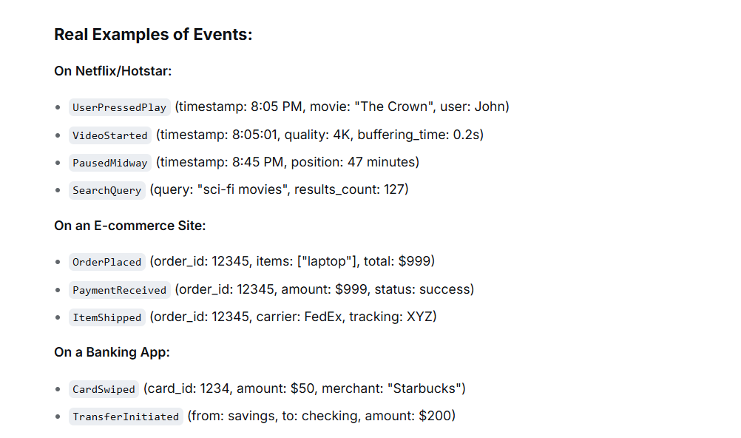
- 📺 How Netflix/Hotstar ACTUALLY Uses Event Streaming

- 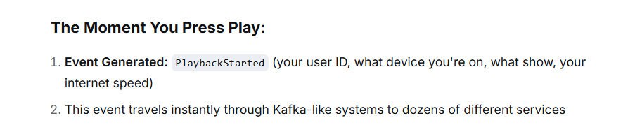

- 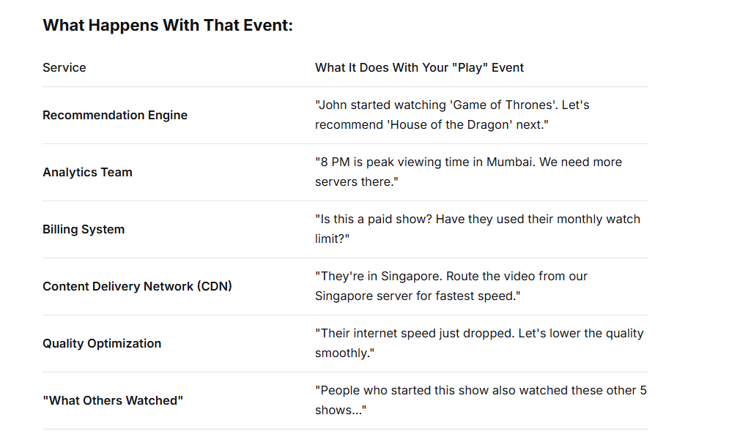

- The above shows that when an event occurs, all the services related to the process listens to the event and start executing their process.

- 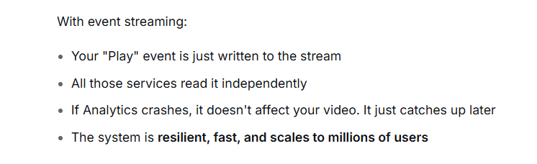
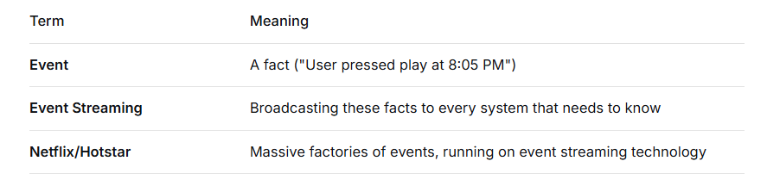

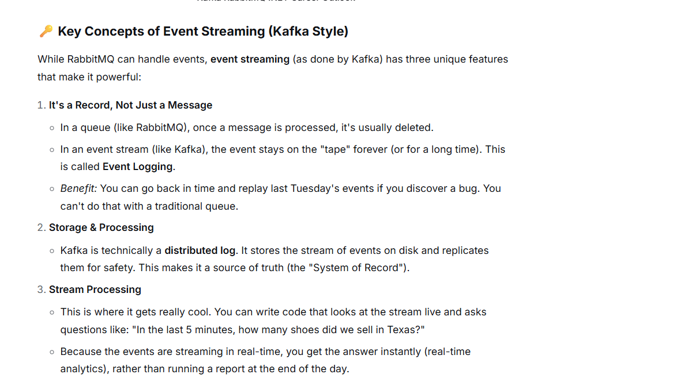
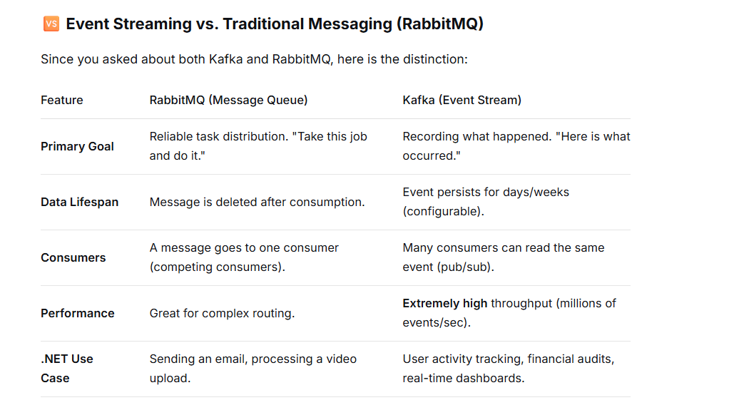

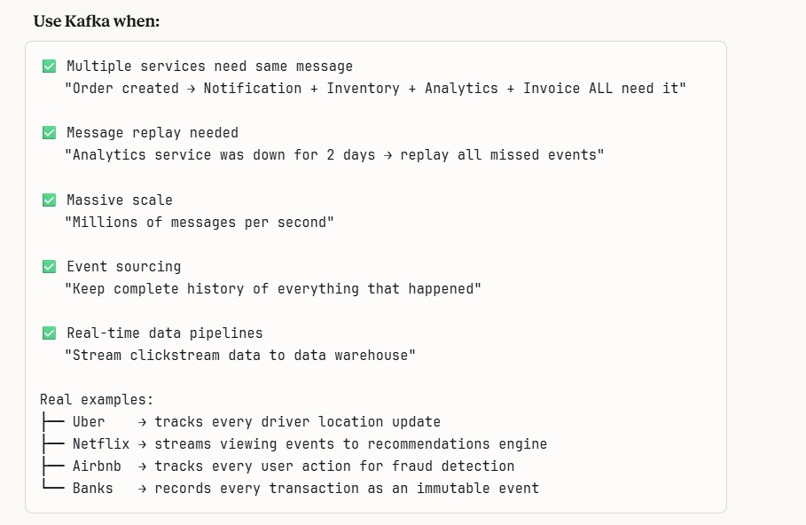
Terminologies used in Kafka
  - Broker – it is a Kafka Server – stores messages and serves them to the consumers.
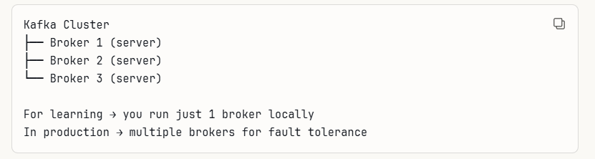
  - Topic – a named channel where the messages are published, like a category or folder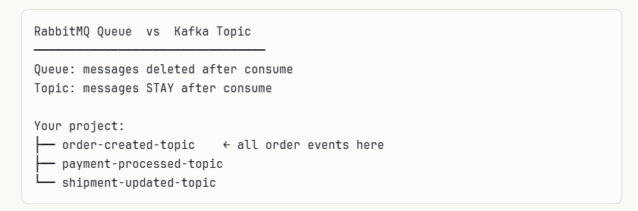
  - Partition – a topic is split into partitions for parallel processing. This is the kafka’s secret to speed
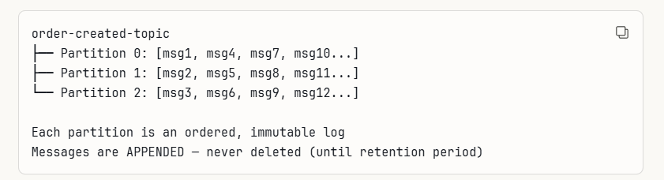
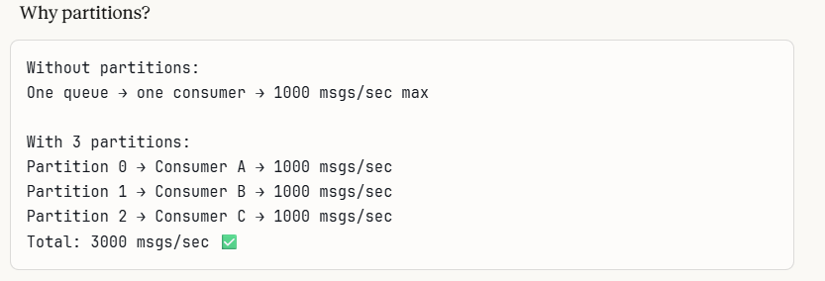
  - Offset – a unique sequential number is assigned to each message with a partition
,like a page number in the book
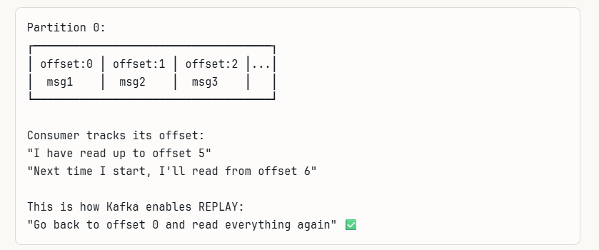

  - Producer – it is the service that “publishes the messages to a kafka topic”
In our project it is “Order.API”
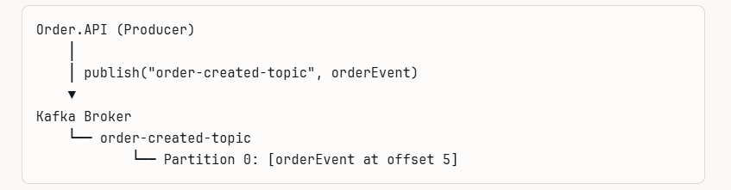

Here producer is there
- Kafka broker -broker
- Order-created-topic- topic
- Partiion 0 – it is a partition
- Offset 5 – offset

- Consumer – it is the service that reads from a Kafka topic. In our project – Notification.API
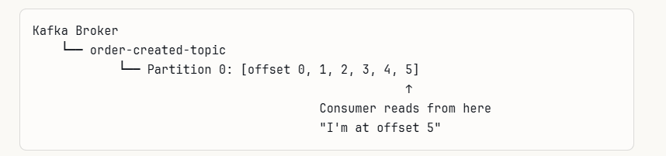
- Consumer Group – it is a group of consumers that work together to process a topic
Each partition is assigned to exactly one consumer in the group
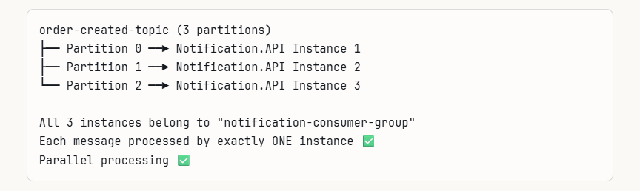
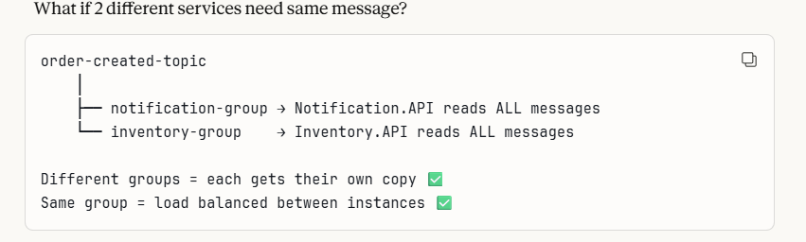

- ZooKeepr/Kraft – kafka traditionally used Zookeeper to manage Cluster coordinations. New versions use Kraft (it is kafka’s own consensus protocol)- so no zoo keeper needed.
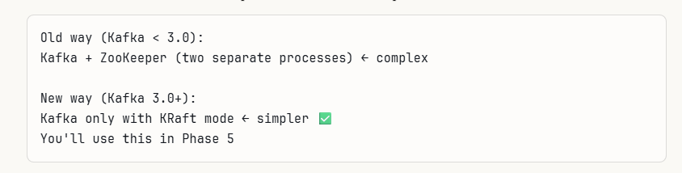

HOW KAFKA WORKS IN YOUR PROJECT

Right now with RabbitMQ:
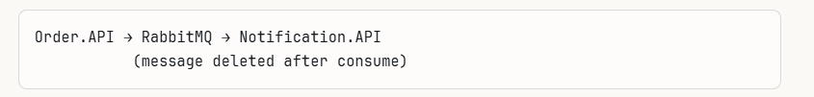

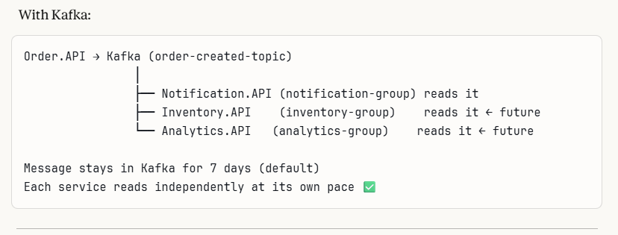
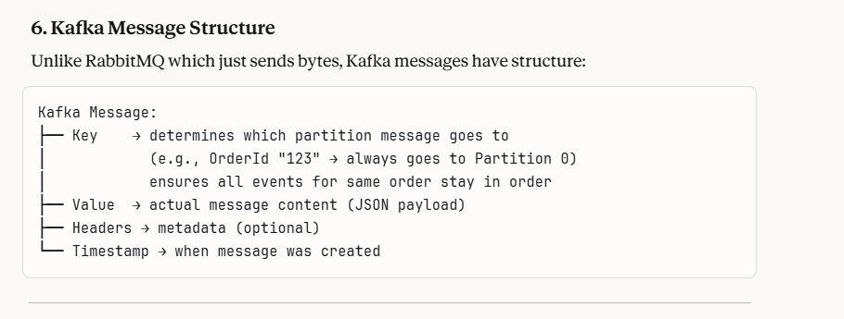
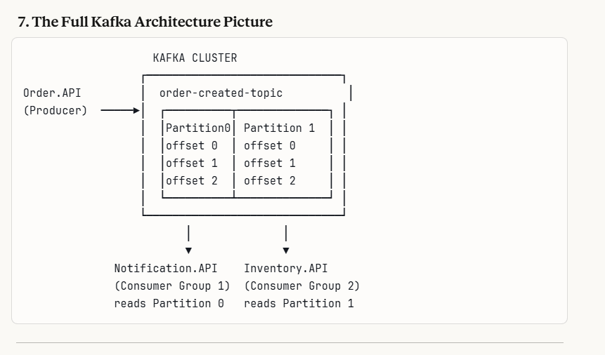
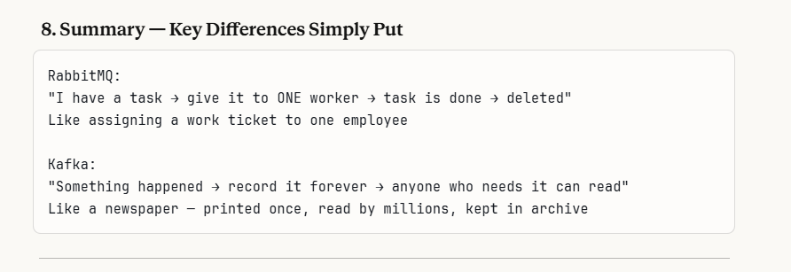

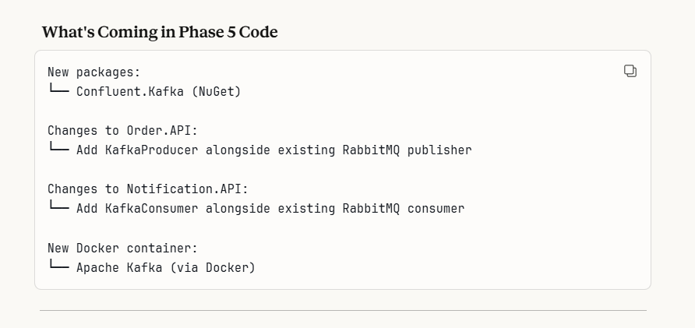

Before moving to next we see the basic related terms:
- What is a cluster ?
It is a group of servers working together as one unit
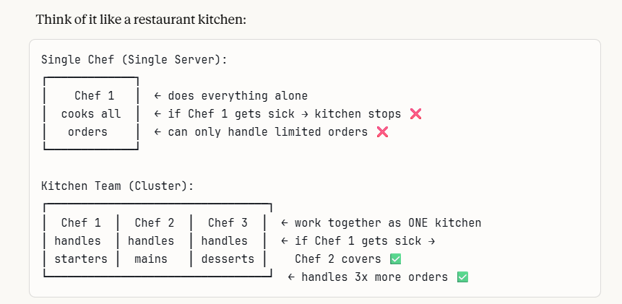

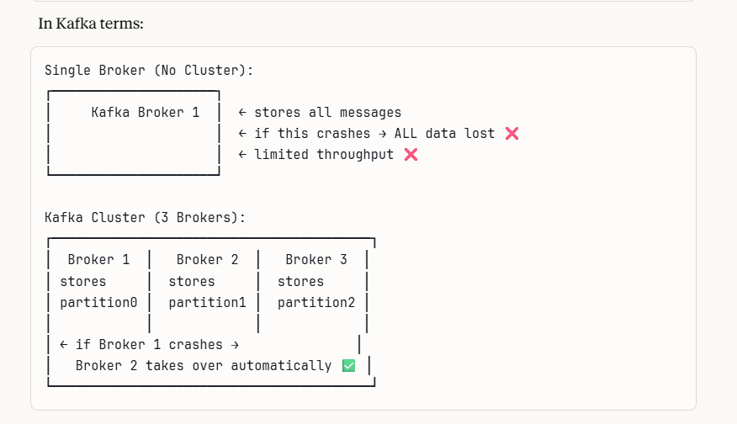
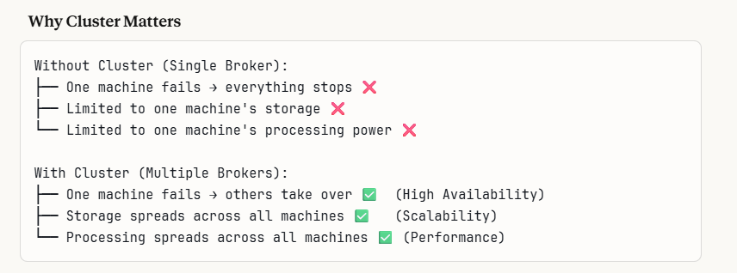
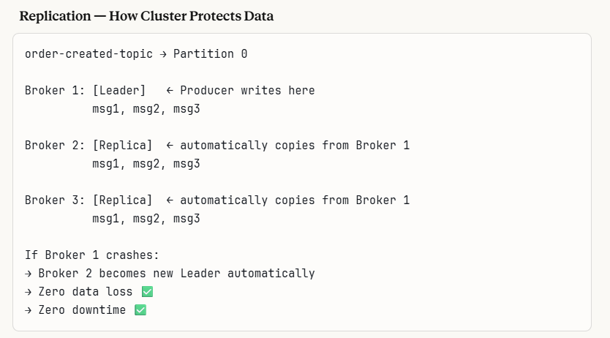

Here Broker are separate servers

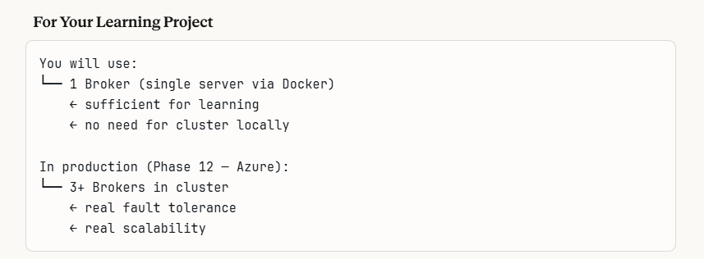

Who Decides Partitions and Offsets?

Partitions: YOU decide (the developer/architect)

- When creating a topic , as a developer you specify the number of partitions
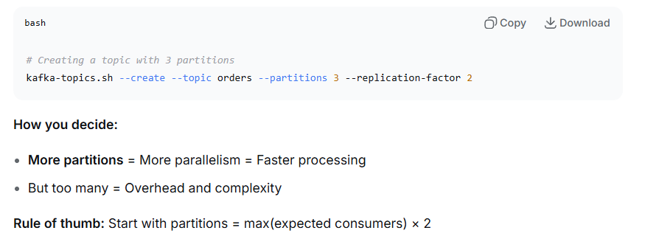

Kafka theory is over, now we shall move to practical solution.”kafka practical

